Self-Assessment: My Coaching Wheel – iCK Pledge – 10 Golden Rules

Here is a reminder of the 10 Golden Rules

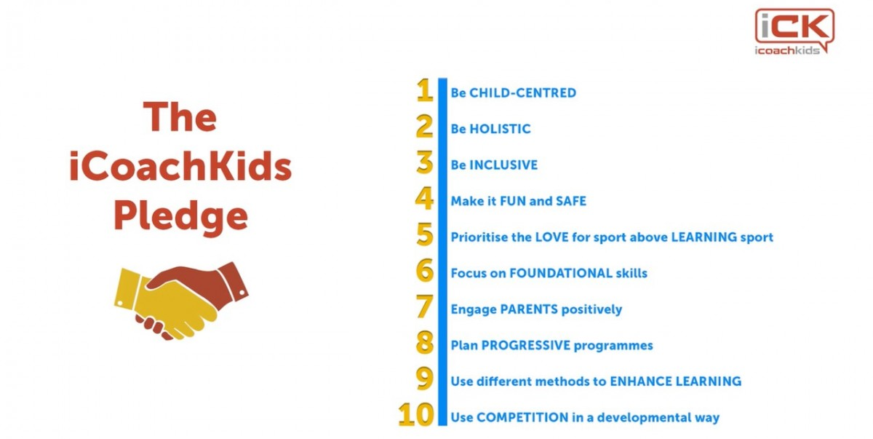

Please highlight the self-assessment score (1 to 10) in each section of the wheel

Rule 1
1 2 3 4 5 6 7 8 9 10

Rule 10 Rule 2
1 2 3 4 5 6 7 8 9 10
1 2 3 4 5 6 7 8 9 10
10 9 8 7 6 5 4 3 2 1

Rule 9 Rule 3
10 9 8 7 6 5 4 3 2 1

10 9 8 7 6 5 4 3 2 1
1 2 3 4 5 6 7 8 9 10
Rule 8 Rule 4
10 9 8 7 6 5 4 3 2 1
1 2 3 4 5 6 7 8 9 10
1 2 3 4 5 6 7 8 9 10

Rule 7 Rule 5

Rule 6
Now, pick the area where you feel you have most potential to improve and that will make the biggest difference to the children you coach and in the table on the next page explain why you rated yourself the way you did and what you plan to do to do better going forward

Please repeat for each of the other 9 areas

When you finish it upload it to your portfolio using the upload button

Rule No. | Rating | Why Do You Think This Area Can Be Improved? | I will do …… to do better going forward

