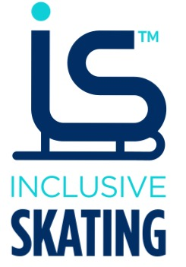

Sport Coaching: Inclusive Skating

Coaching Mentor Log Records

Name –
Date –
Mentor –
Location
Session (Delete as appropriate) – Individual / Group
Participants Age
Participant Additional Needs
Participants Ability
Session Plan
Session Plan’s relationship to the annual training plan

What skills did you plan to teach during this session

What pedagogical tools do you plan to use?
What coaching styles, communication skills and pedagogical tools did you use during this session?

How did you check for understanding and meet Participant Additional Needs?

Did you make any adjustments to respond to participant need’s
Give an example of what worked well and how you helped a learner/learners within this session:

How could you ensure continuity to the next session for these participants, and adjust the training plan for the participants

Give a brief evaluation of this session: i.e. How well did it run/ What did you learn/ What went wrong/right/ How would you deal differently with similar situations in the future?

Feedback from Skaters, Team Members and Mentor
Signature

Date

Mentor
Signature

Date

Trainee coach

